

Mob : +44 (0) 7940 233 592Email: [robert.haynes@sugarflowerstudio.co.uk](mailto:robert.haynes@sugarflowerstudio.co.uk)Web : [**www.sugarflowerstudio.co.uk**](http://www.sugarflowerstudio.co.uk)

**Glazing Information**

**Wet glazing method**

Why do I wet glaze? I choose this method as I much prefer the outstanding results it gives you, as wet glazing sets and beautifully blends all of the coloured dusts together. An alternative is steaming, however, unlike steaming; the glaze reaches every part of the whole flower, petal or leaf that you are working on.

A scenario: If you had made a light or even a dark, coloured celebration cake and decorated each tier with an arrangement of steamed sugar flowers and leaves, you may experience uneven road vibrations during transit to the venue. This might lead to unsightly petal dust marking the cake surface - unset, loose dust colours may fall, or come off through contact and blemish the cake.

**Items needed for Wet Glazing**

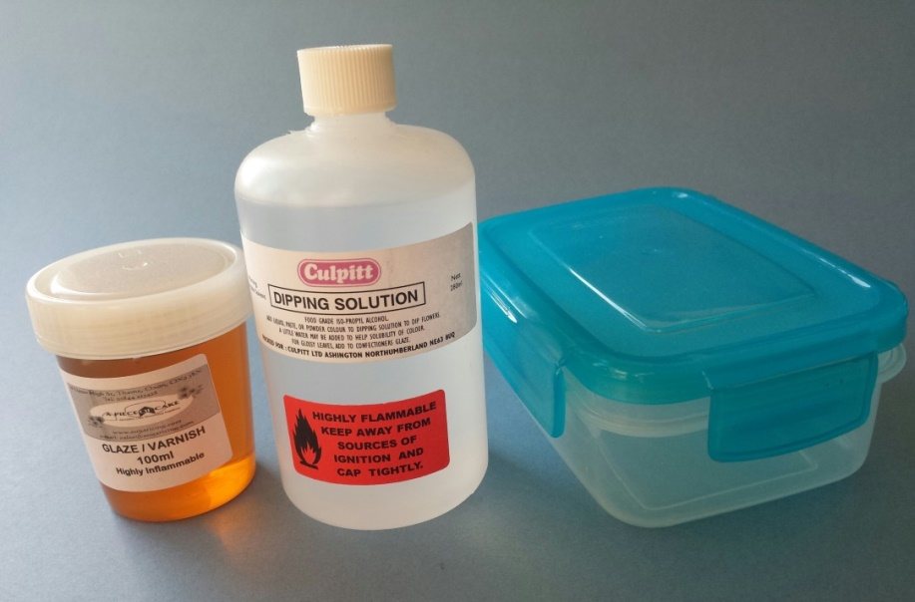

* Liquid Confectioners Glaze
* Isopropyl Alcohol (IPA)
* Airtight storage containers, approx. 8 inch square
* Large plastic spoons
* Oasis/Styrofoam/polystyrene blocks
* Large disposable container, such as a cardboard box, approximately 12 inch x 20 inch
* Old newspapers and disposable waterproof table covering

In a class environment it is easy to break your petals and leaves. There is so much going on and distractions, or not planning your route, often lead to students banging into each other and dropping their work. *Make sure the table is fully covered with old newspapers and disposable waterproof covering before starting the glazing process.* (I sometimes wrap the table in cling film.)

Liquid Confectioners Glaze is usually mixed with Isopropyl Alcohol (IPA) for use on sugar flowers. The mix should be stored in an airtight container. There are many brands of Confectioners Glaze and IPA available on the market. Always try to use 95% IPA, or higher, as a lower percentage will result in the glaze separating when mixed together.

**Dangers of IPA**

IPA is highly flammable - KEEP AWAY FROM A NAKED FLAME!

IPA Is dangerous if swallowed, it isn’t made for consumption, however it is used in sugar craft because the alcohol evaporates quickly. Mark the bottle carefully with a “Danger Do Not Drink” sign. Keep in a high cupboard out of reach of children.

Always use in a well ventilated room, replace the lid when not in use, especially in a class environment

**Ratio of Glaze and IPA**

The darker coloured liquid confectioners glaze is the shiny part of the glazing technique, so the more you put in the shinier your finished petal or leaf will be. For a very shiny end result, such as on a Blackberry or Holly berry, no IPA is required. Simply dip the berry into the **full glaze** and spin off the excess into a throw away container.

A **Half Glaze** is measured using 50% of Glaze and 50% of IPA combined an airtight container. So to make up 100ml of half glaze combine 50ml glaze with 50ml IPA. This is used for a slightly shiny end result i.e. a Rose leaf

A **Quarter Glaze** is measured using 25% of Glaze and 75% of IPA combined in an airtight container. So to make up 100ml of quarter glaze combine 25ml glaze with 75ml IPA.

|  |  |  |
| --- | --- | --- |
|  | Confectioners Glaze | IPA |
| **Full Glaze** | 100% | None |
| **Half Glaze** | 50% | 50% |
| **Quarter Glaze** | 25% | 75% |

In a class environment I always use a quarter glaze. I can add further shine if needed by spraying the leaves with a clear PME confectioners spray. I tend to tape up the whole plant first, then in a well ventilated room, spray short fine layers from about 8 inches away. Be careful not to put too much on as it will run and leave thick drip marks.

**The Glazing process**

* Place the dry leaves and petals into your oasis or Styrofoam or polystyrene block, make sure the wires are not too long to stop them from waving around when you carry them
* Always make sure you wash your hands before glazing as any dust powder on your hands will be very hard to remove after if you get glaze on top - it’s like a varnish!
* Make sure the floral wire is straight; this makes it much easier to spin the excess glaze off.
* If your leaf is very long then simply putting 2 fingers around the paste covered wire, bend at a right angle so you can immerse it fully into the glaze, then remove from the glaze, careful not to touch the sugar, bend the wire back straight and spin excess glaze off.
* You can also use a large plastic spoon to wash the petal with glaze if it is too large to fit inside the glaze bath container. (I do this procedure for a finished full rose)
* Keep the petal or leaf down inside the disposable container (normally a cardboard box in class), be careful not to get the table or floor covered in the glaze, as it is very hard to remove.
* Spin the wire continuously inside the disposable container until you see no more residue coming off, then place into the oasis/Styrofoam/polystyrene block to fully dry.
* Manage your oasis/styrofoam/polystyrene block; I like to group all of one type of leaf from one flower at one side and another variety on another side.

**Cleaning glaze & container**

When you immerse many green leaves into the glaze it will take on the dyed green pigment colour, you can never get rid of this colour. I have numerous air tight containers for different coloured petals etc. I have a separate container for greens, reds, blues, yellows, pinks and clears and have had them for years. There will be a build-up of dust residue at the bottom of the glaze, do not touch this with the petal, leaf or flower you are dipping as it won’t come off the finished glazed flower.

To clean out the container simply transfer the liquid through kitchen paper towel or a coffee filter paper into a fresh clean container. Clean out the residue with paper towel and discard, then repeat the filtering process back into the cleaned container. You now have a dust free glaze, but you will never be able to remove the pigment colour. I actually prefer a stained green glaze as it helps with a better finished colour when glazing leaves.

**Steaming technique**

Whilst I prefer to wet glaze, steaming is a much quicker and simpler procedure. I tend to steam the fully finished flower with attached leaves.

I use an industrial curtain steamer to steam my finished flowers so that I don’t need to stand with one hand permanently on the kettle button! Hold the sugar flower about 8 inches away from the steam; I usually put my hand through the steam mist to gauge where the heat is… **be careful!!**

Turning the flower around and through the steam, turning the flower upside down as well, the steam penetrates most areas. The heat will slightly melt the sugar which will absorb the coloured petal dusts or painted areas and set the colour to give you a dust free surface. Steaming is also used to darken colours especially greens for ivy, rose & holly leaves.

Try not to “over steam” as the petals become limp, once dry they have a slightly dull waxy finish to them. Turning the flower around in the steam a few times should be ample.

Sometimes steam doesn’t penetrate deep into the centre of a tightly spiralled rose or reach the base of a fully taped up finished flower, for example a Hibiscus or Lily (trumpet shaped flower). By the time the steam has penetrated deep into the centre, by holding the flower upside down, the fine edges of the petals have become over steamed, so when dry they have a slightly waxy appearance.

**After Steaming and Glazing**

It is possible to go back and re-dust a petal or leaf after Steaming and Glazing but this must be done within 5 minutes really as the sugar creates a barrier which, after time, becomes less absorbent and difficult to penetrate with colours.